

Mini Project Report

on

**ClimateSync - A Web Platform for Real-Time Environmental Awareness and Sustainable Practices**

For the course

**Web Programming Laboratory**

Submitted by

**Aayush Hardas**

Roll No: 16010123013

**Aditya Sontakke**

Roll No: 16010123022

Guide

**Deepa Jain**

**Department of Computer Engineering**

**K. J. Somaiya School of Engineering**

**Somaiya Vidyavihar University**

**DECLARATION**

I declare that the written Mini Project report submission represents the work done based on my and / or others ideas with adequately cited and referenced the original source. I also declare that I have adhered to all principles of academic honesty and integrity as per norms of the Somaiya Vidyavihar University. I have not misinterpreted, fabricated, or falsified any idea/data/fact/source/original work/matter in my submission.

I understand that any violation of the above will be cause for disciplinary action by the university and may evoke the penal action from the sources which have not been properly cited or from whom proper permission is not sought.

|  |  |
| --- | --- |
| **Roll No: 16010123013**  **Student Name: Aayush Hardas**  **Signature** | **Roll No: 16010123022**  **Student Name: Aditya Sontakke**  **Signature** |

**Date: 21.04.2025**

**Place: Mumbai-77**

**Application Web Development: ClimateSync**

**Literature Review :**

Climate change is no longer just a global issue discussed at international summits, it’s something we experience in our daily lives. Whether it’s poor air quality, unexpected temperature spikes, or general uncertainty about how our actions affect the environment, these challenges are real and growing. As students who care about the future of our planet, we felt it was important to explore how technology — especially web development — can play a role in raising awareness and encouraging action.

The United Nations’ Sustainable Development Goals stress the importance of taking urgent climate action and involving local communities in the process (UN, 2015). Studies also show that people are more likely to engage with environmental issues when the information is made accessible, personalized, and easy to understand.

There are already platforms out there that focus on live environmental data — for example, AQICN.org provides real-time Air Quality Index data for cities around the world. However, most of these tools stop at just showing the data. Others focus more on awareness but don’t update users with live information. We noticed that something was missing — a bridge between knowing and doing.

That’s where ClimateSync comes in. It’s a web platform we developed to make climate awareness interactive, useful, and local. Our site offers:

* Real-time AQI and temperature updates using public APIs,
* A collection of sustainable practices people can try in their daily lives,
* A community engagement section where users can share ideas and take part in environmental conversations.

The goal isn’t just to inform people — it’s to help them take simple, meaningful steps toward sustainability. We wanted to make climate action feel less intimidating and more like something anyone can participate in.

#### References:

* United Nations. (2015). Sustainable Development Goals.<https://sdgs.un.org/goals>
* AQICN.org – Real-time Air Quality Index.<https://aqicn.org>

**Need Statement :**

Despite growing awareness about climate change, many people still lack access to real-time environmental data and practical guidance on how to contribute toward sustainability. While some platforms show air quality or weather data, they often present it in a technical or disconnected way, making it difficult for everyday users to relate or take meaningful action.

As students learning web development, we wanted to create something that goes beyond just displaying numbers. We saw a need for a platform that not only shows live environmental data, like AQI and temperature, but also explains what that data means and suggests eco-friendly actions users can take.

There’s also a lack of digital spaces where users can share their thoughts or community-driven initiatives related to sustainability. By including a community engagement form and a section dedicated to sustainable practices, we aim to make ClimateSync a more inclusive and action-oriented space.

The need for a platform like ClimateSync comes from the realization that tackling climate change isn’t just about policy or technology — it’s also about helping people understand what’s happening around them and making it easy to act on that knowledge. Our website is designed to do exactly that, in a simple, interactive, and user-friendly way.

**Objectives :**

The primary objectives of *ClimateSync* are:

1. **Provide Real-Time Environmental Data**: Display live air quality (AQI) and temperature updates for different cities, helping users stay informed about their surroundings.
2. **Promote Sustainable Practices**: Offer actionable, easy-to-follow eco-friendly practices , customised for each city which will allow users to know which practices(among a lot) to choose to do now . Also users will be able to add their own cities if not present in the database and can add their own sustainable practices .
3. **Enhance Community Engagement**: Create a platform for users to share ideas, discuss sustainability topics, and connect with others who are passionate about climate action.
4. **Foster User Interaction**: Design an intuitive, user-friendly interface that makes accessing and understanding environmental data and practices easy for all users.

**Flow of pages :**

The ClimateSync website is designed to guide users through an intuitive process, ensuring that essential features are available only to registered users. The flow is as follows:

1. **Homepage**:  
   * The homepage prompts users to log in or sign up before they can access any features.
   * Includes Login and Sign Up buttons.
   * Features tab is hidden until the user logs in.
   * Admin users logging in will see an additional Modify button to make direct changes to the database.

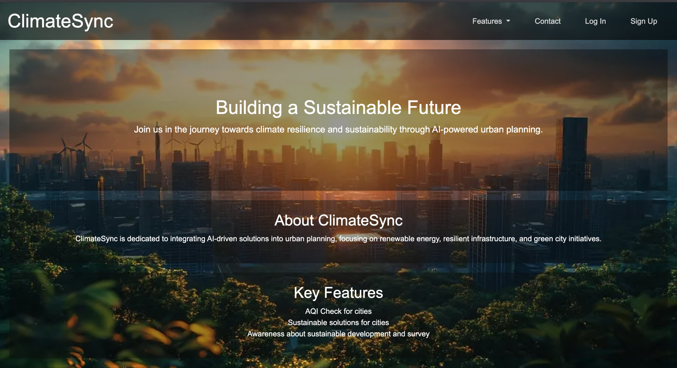



1. **Login Page**:
   * Users must log in with their credentials to access the features.

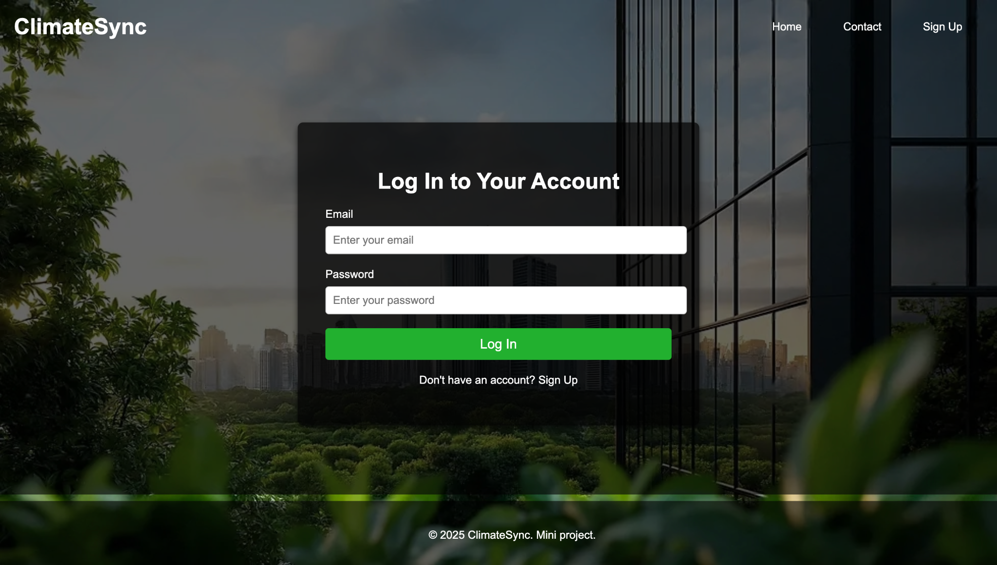

1. **Signup Page**:  
   * 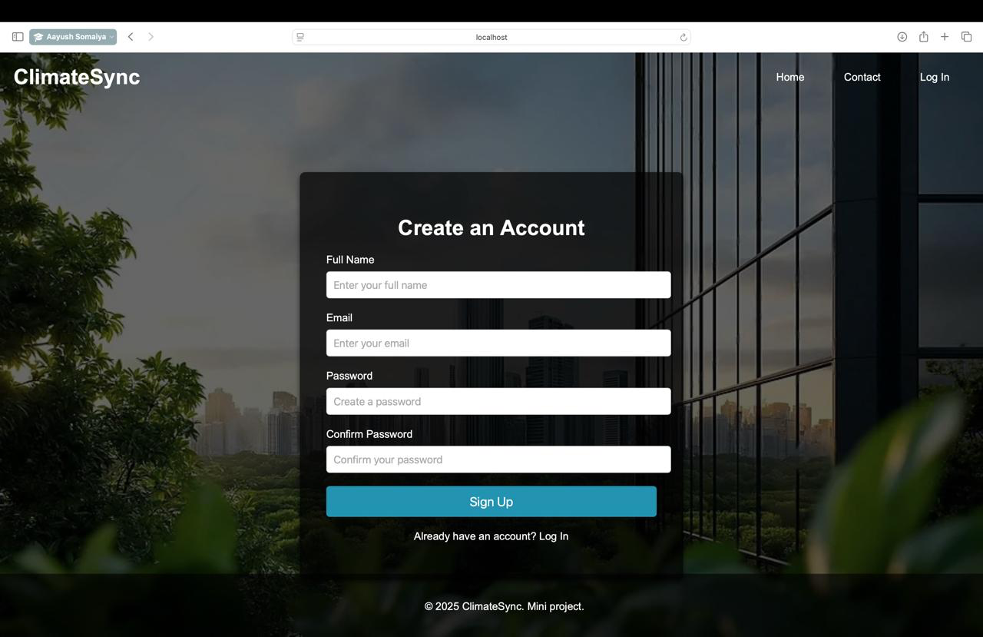New users can create an account to access the platform's features.
2. **AQI Check Page**:
   * Provides real-time AQI and temperature updates for selected cities.
   * Users can input a city to get live data on air quality and temperature.
   * Also has a slider indicating the air quality.

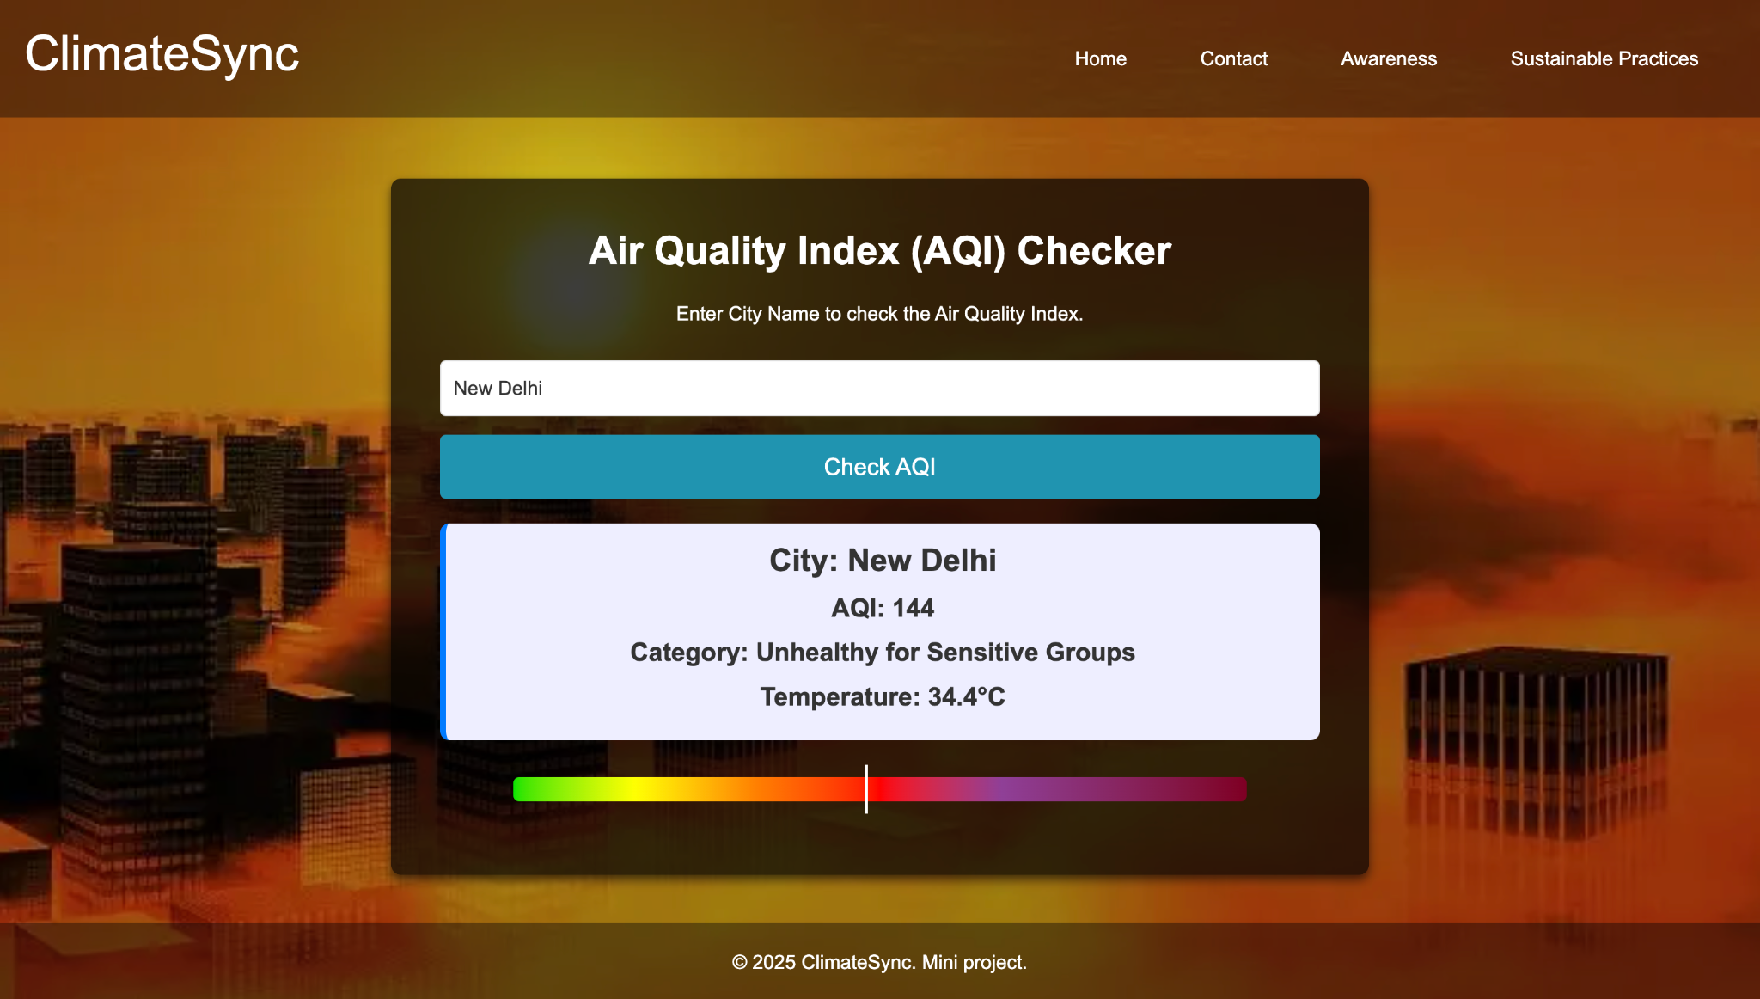

1. **Static Awareness Page**:
   * Lists 5-6 of the most necessary and urgent sustainable practices for today’s situation.
   * Aimed at educating users on key practices to adopt immediately.

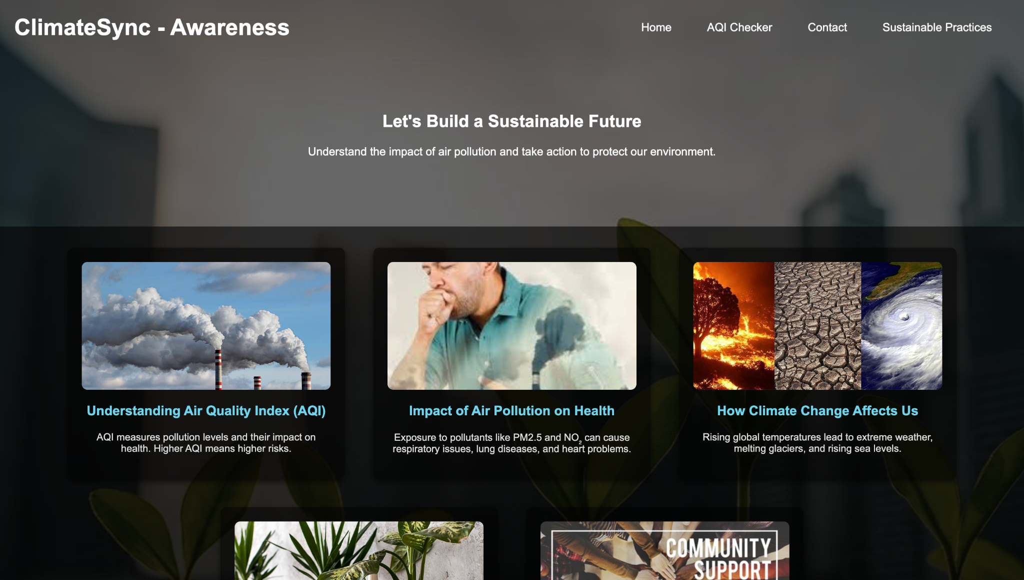

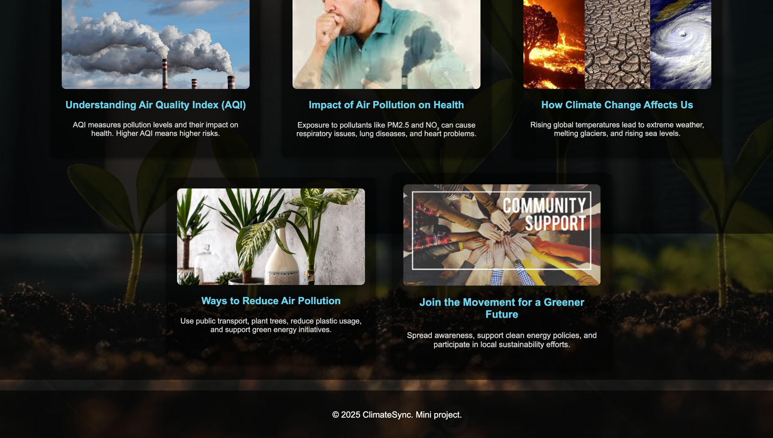

1. **Sustainable Practices Page**:
   * Displays three essential sustainable practices for a selected city.
   * Users can also add their own city and sustainable practices.

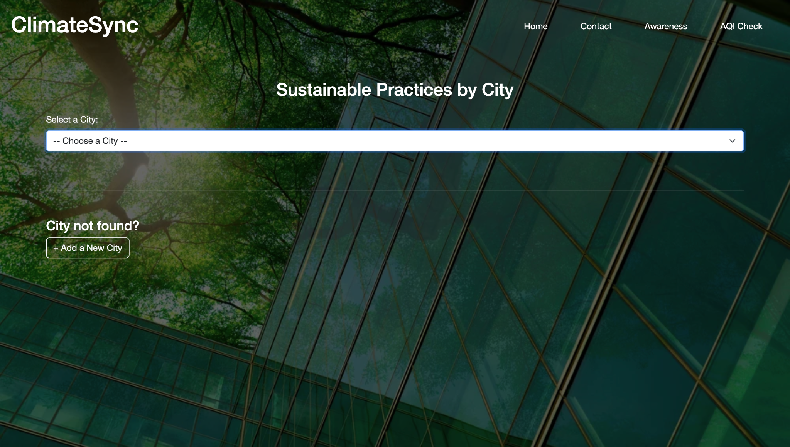

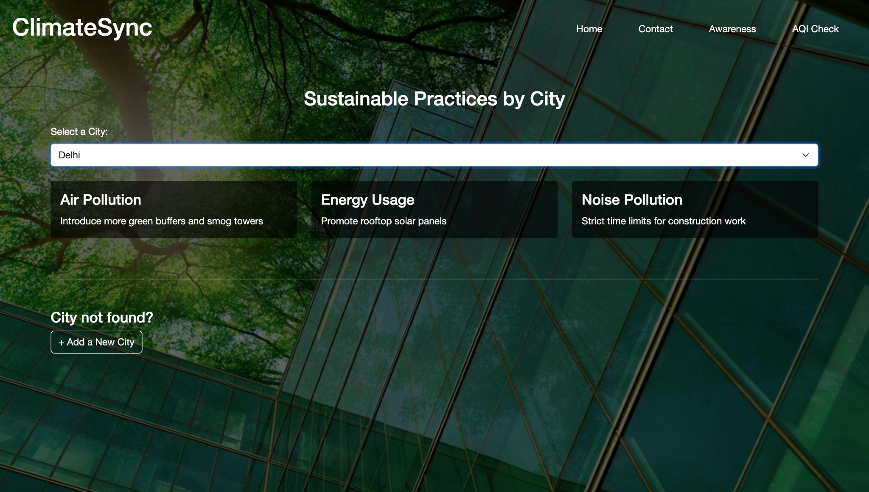

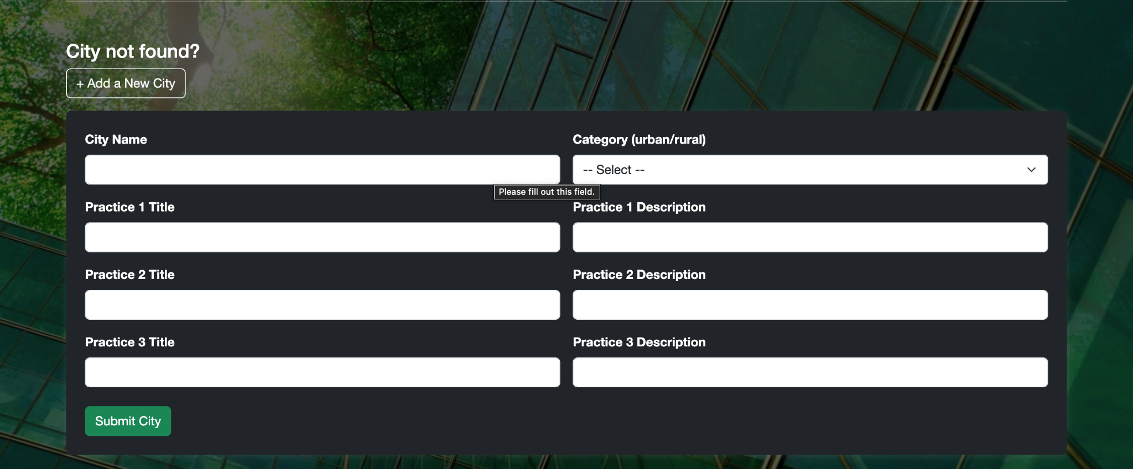

1. **Community Engagement Page**:  
   * A space for users to share ideas, engage in discussions on sustainability, and offer feedback.

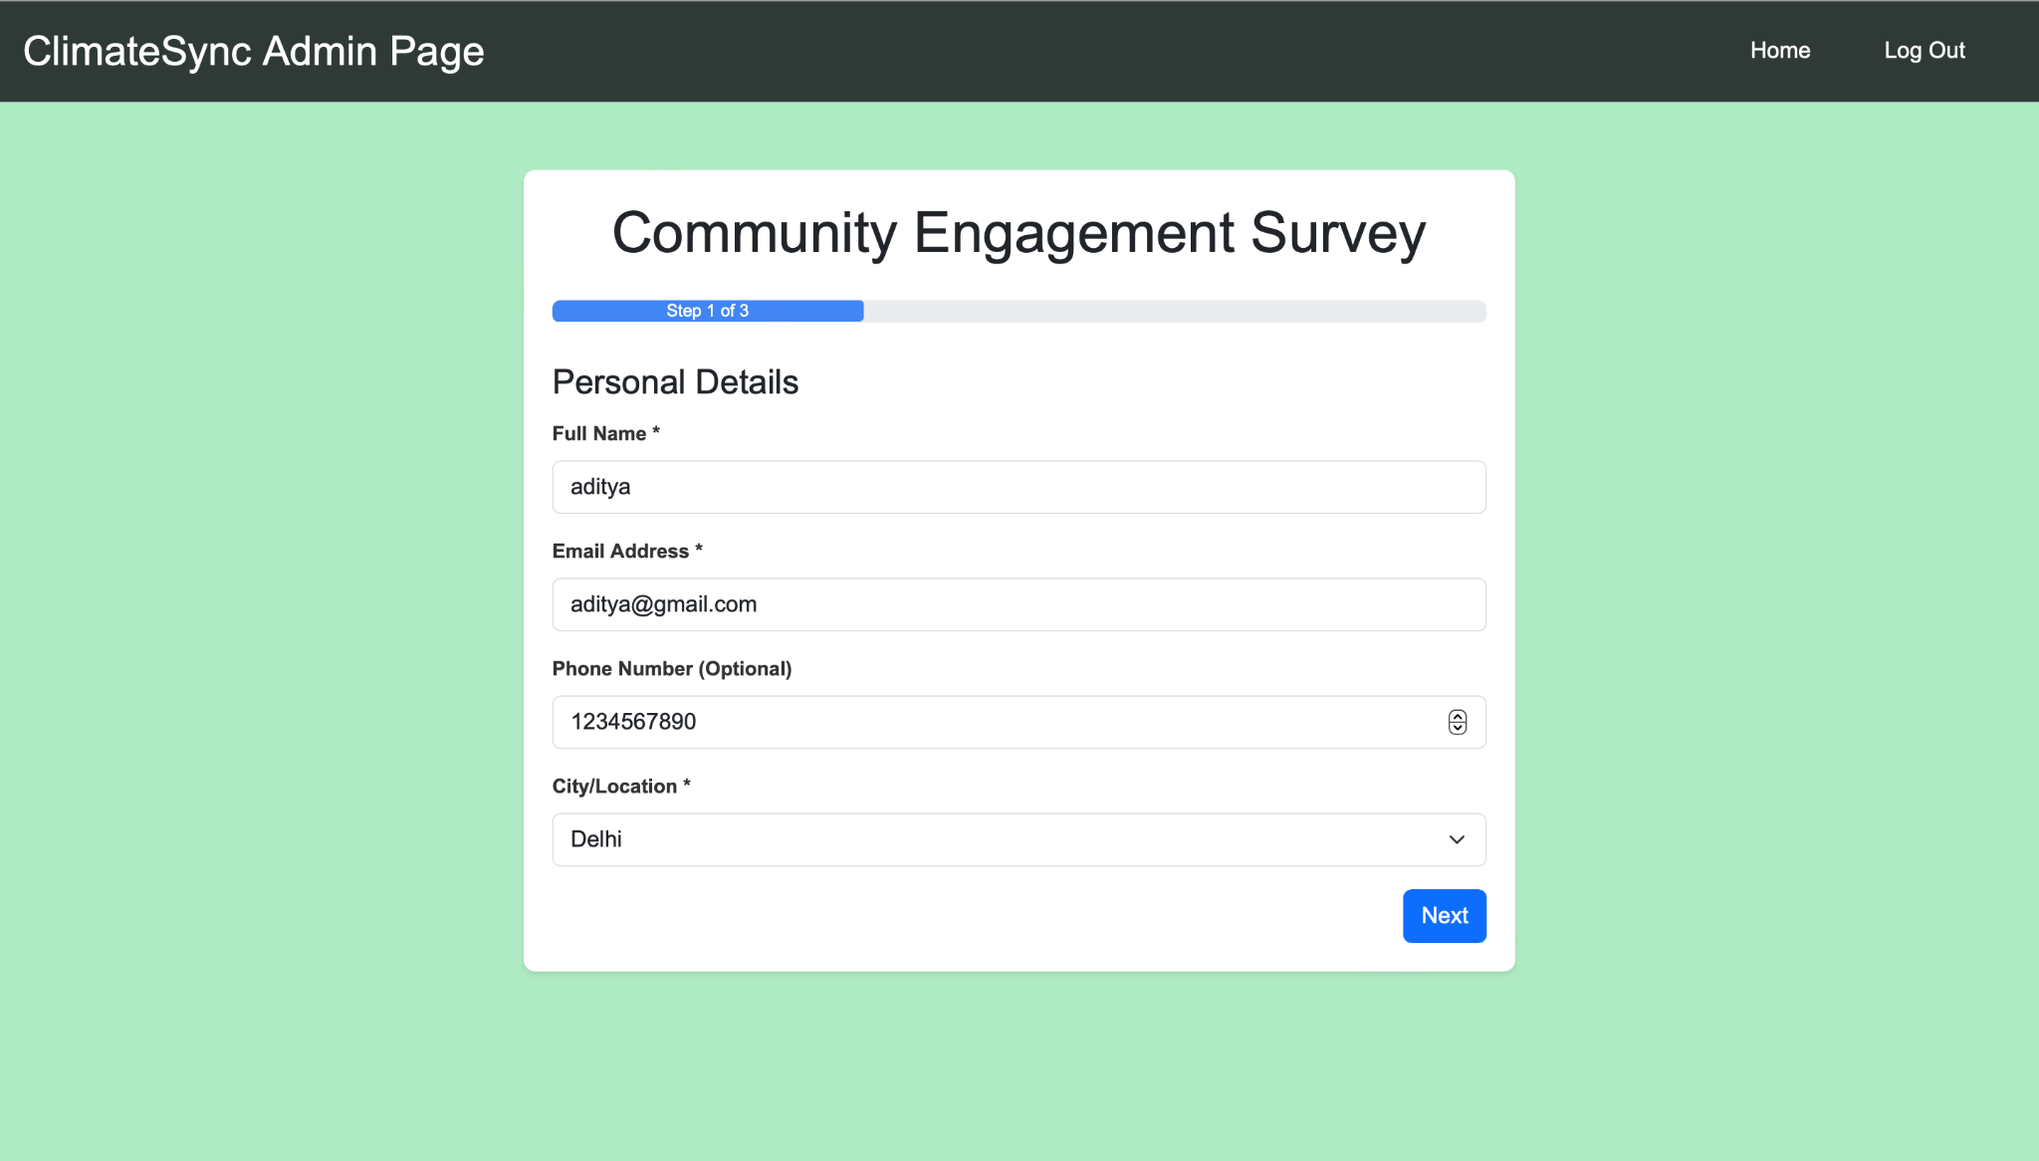

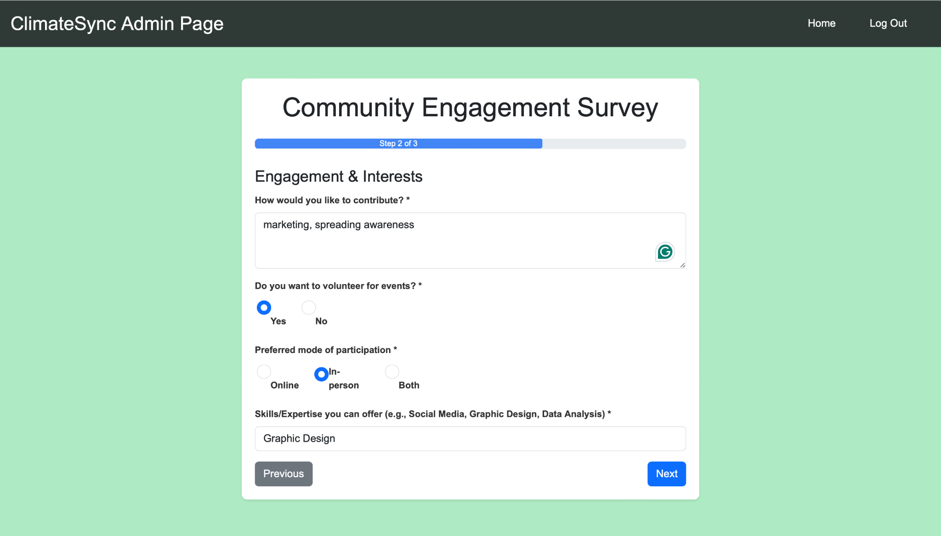

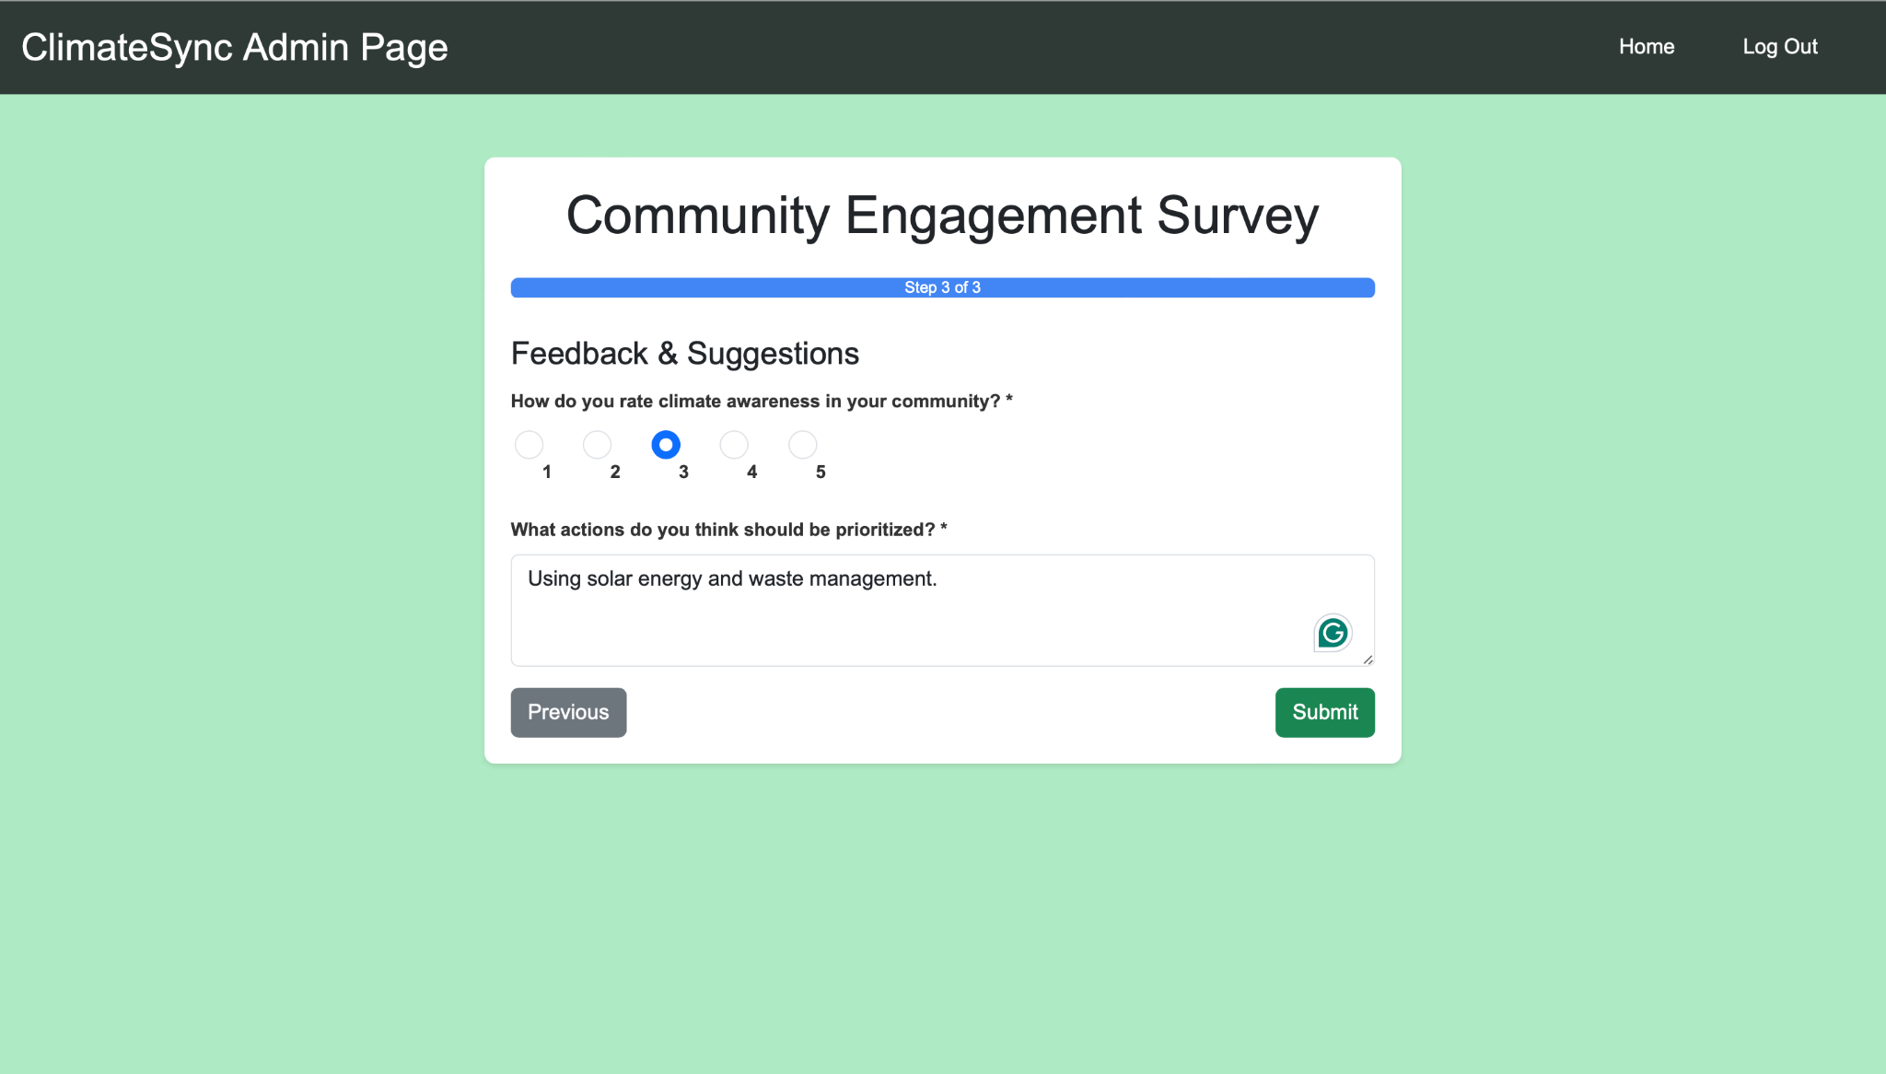

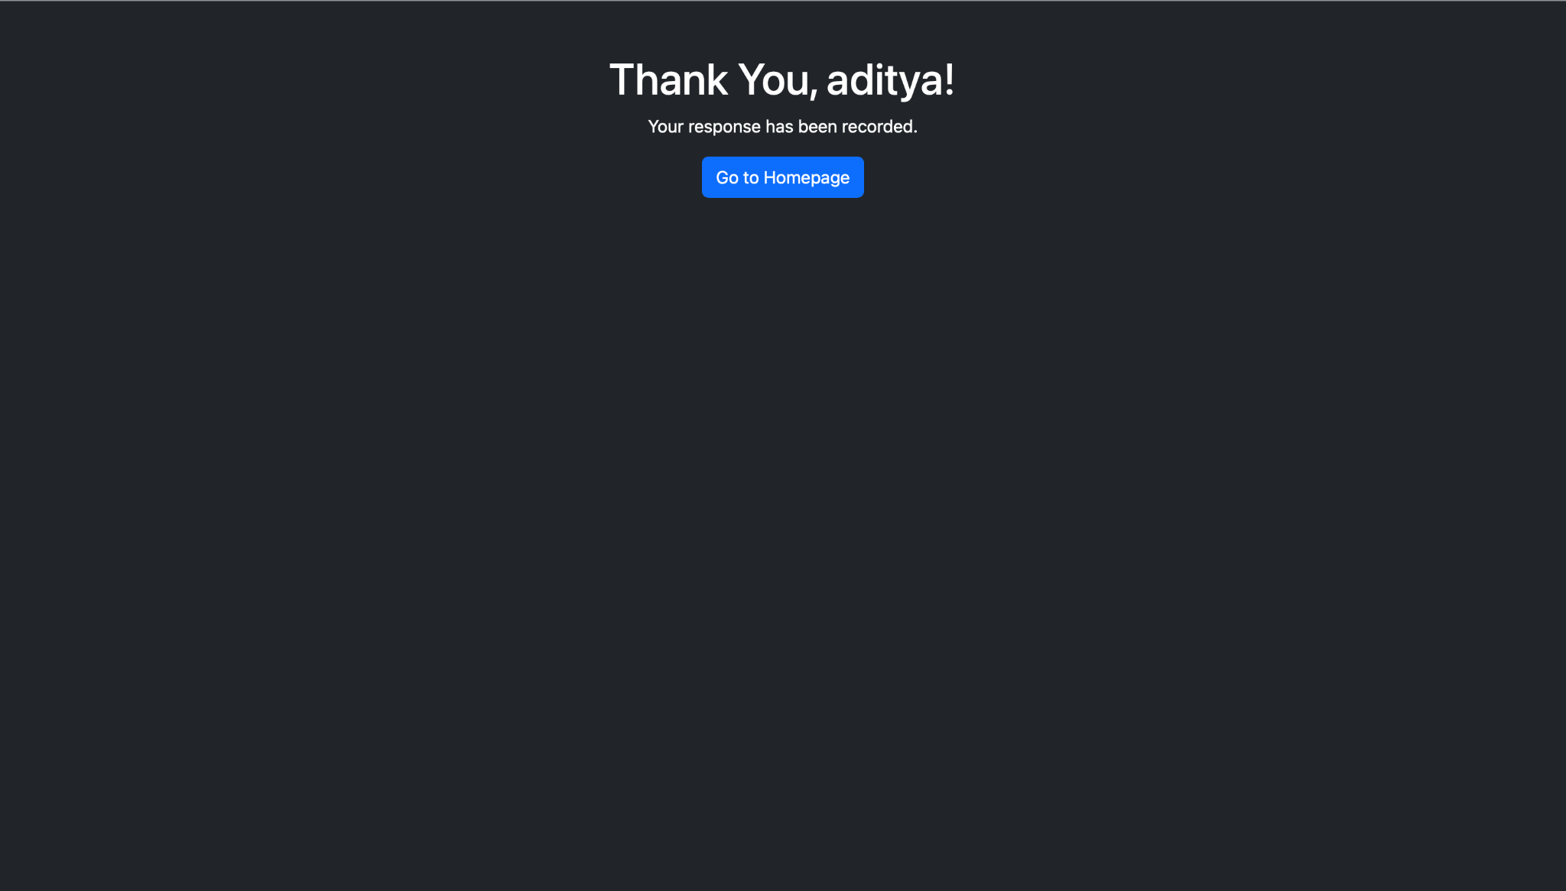

1. **Contact Page**:  
   * Provides users with a way to get in touch with the team for any queries, suggestions, or collaborations.

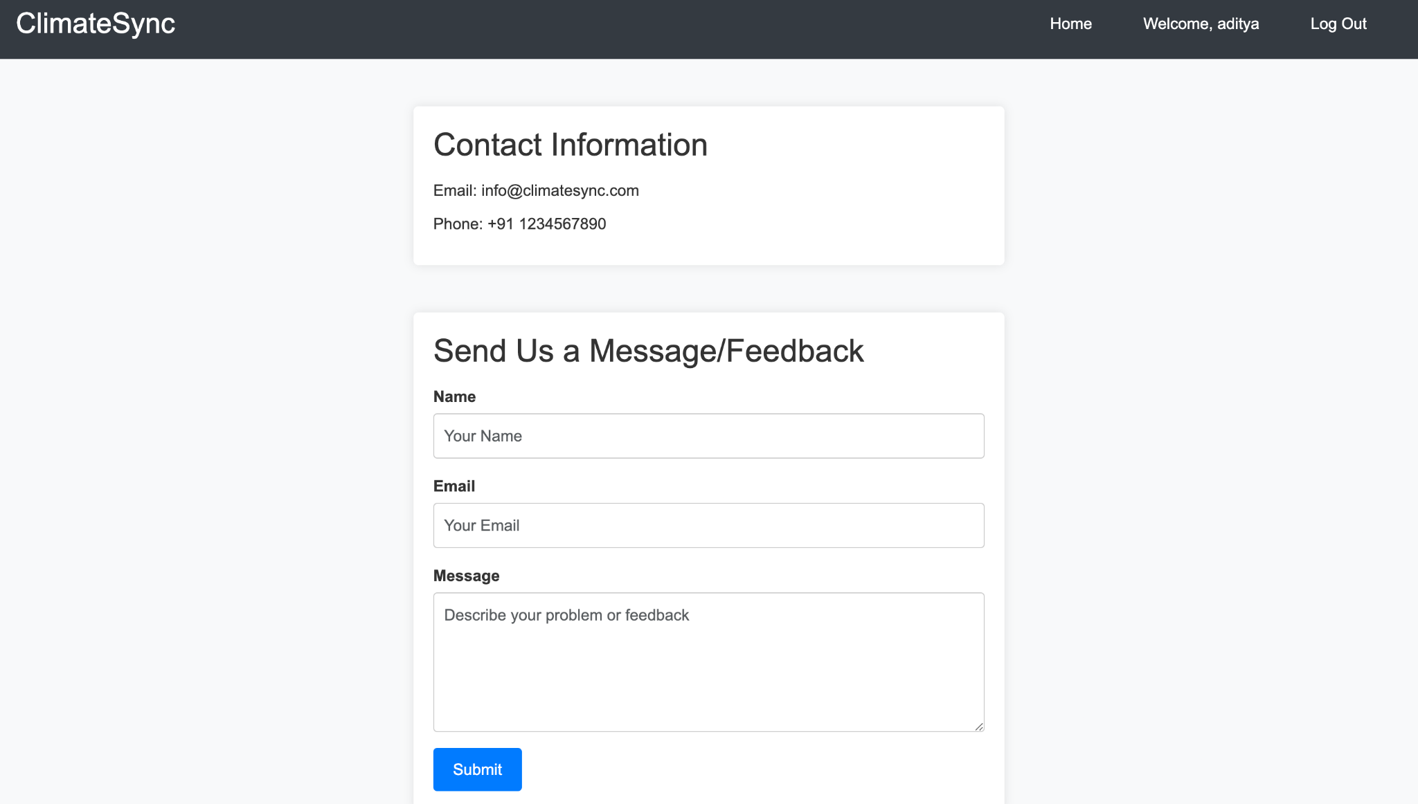

9. **Modify page (Admin Exclusive) :**

* + 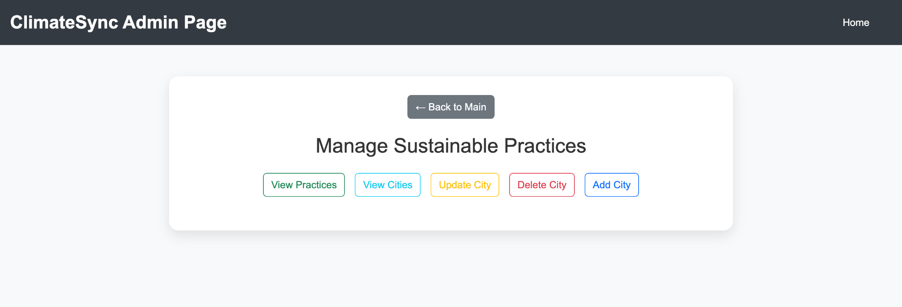If in login , admin credentials are entered an exclusive admin feature ‘Modify’ will be available in the homepage which will allow the admin to make changes in the database without actually opening the phpmyadmin . 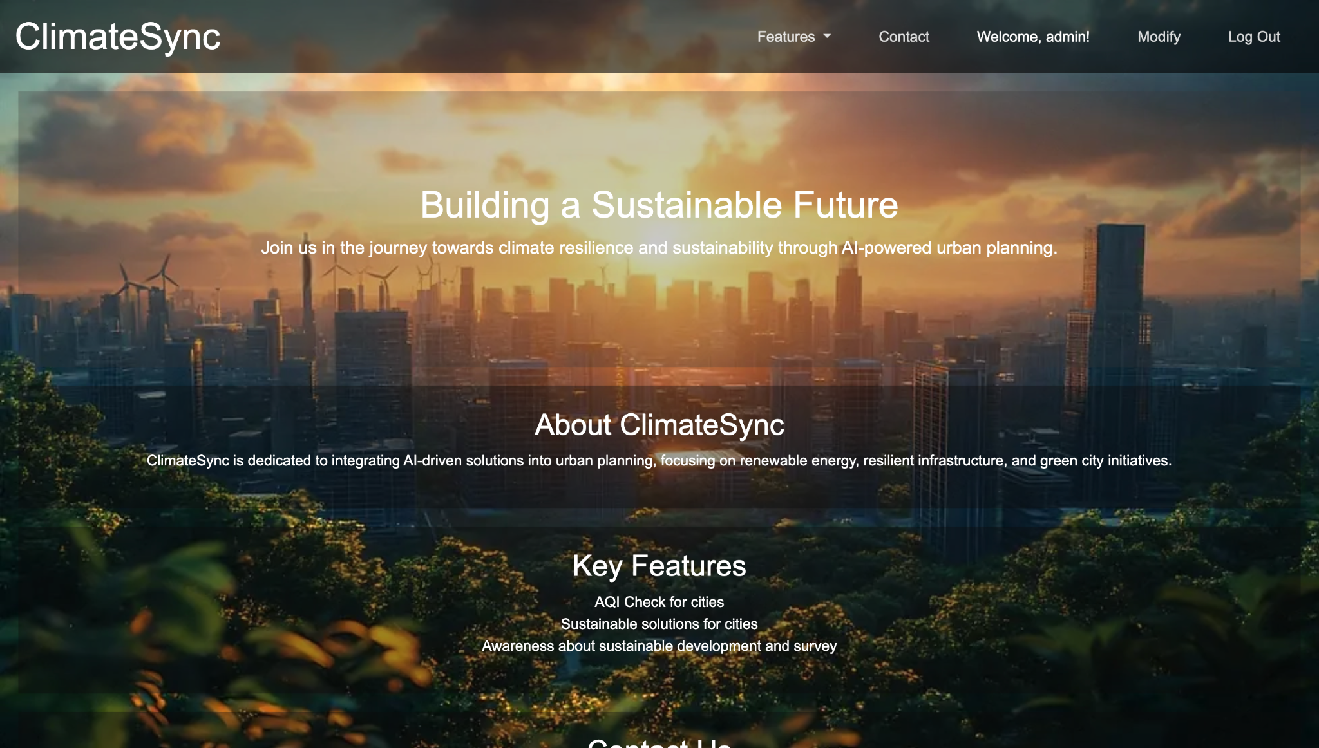

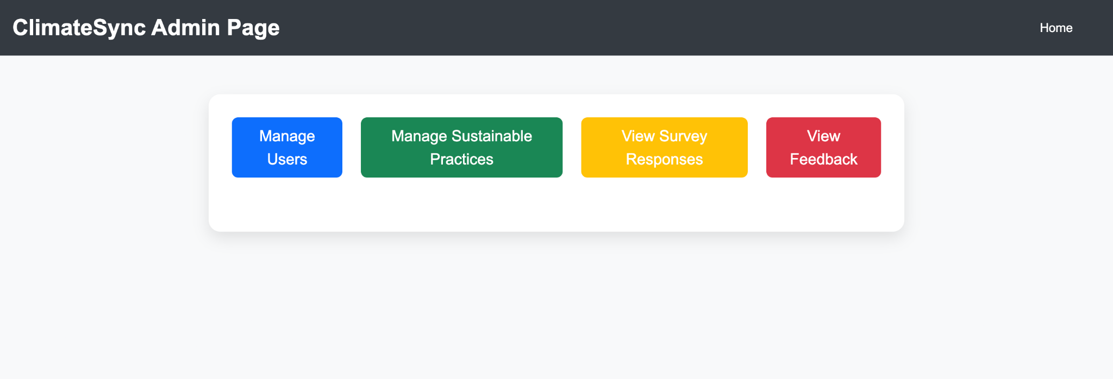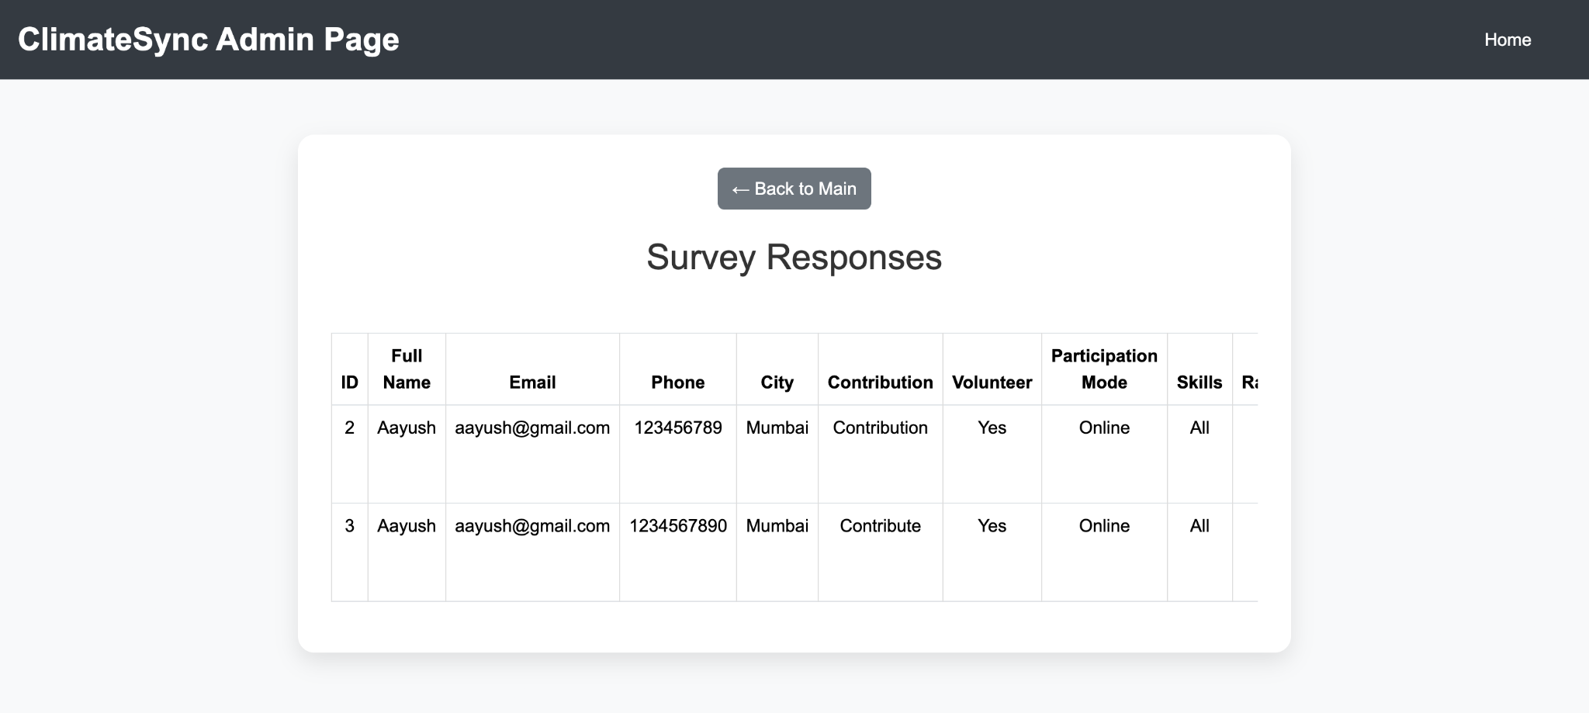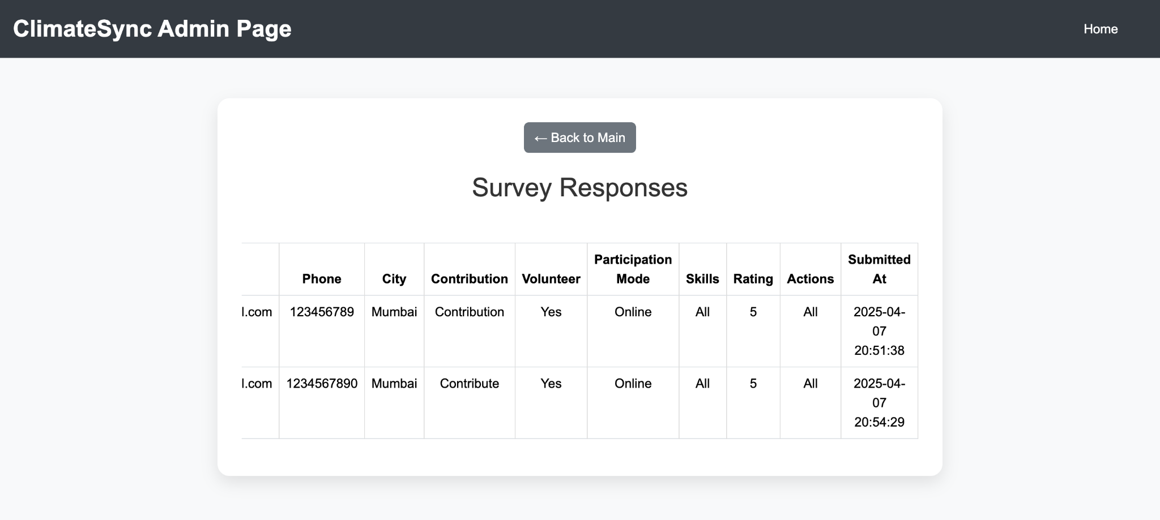

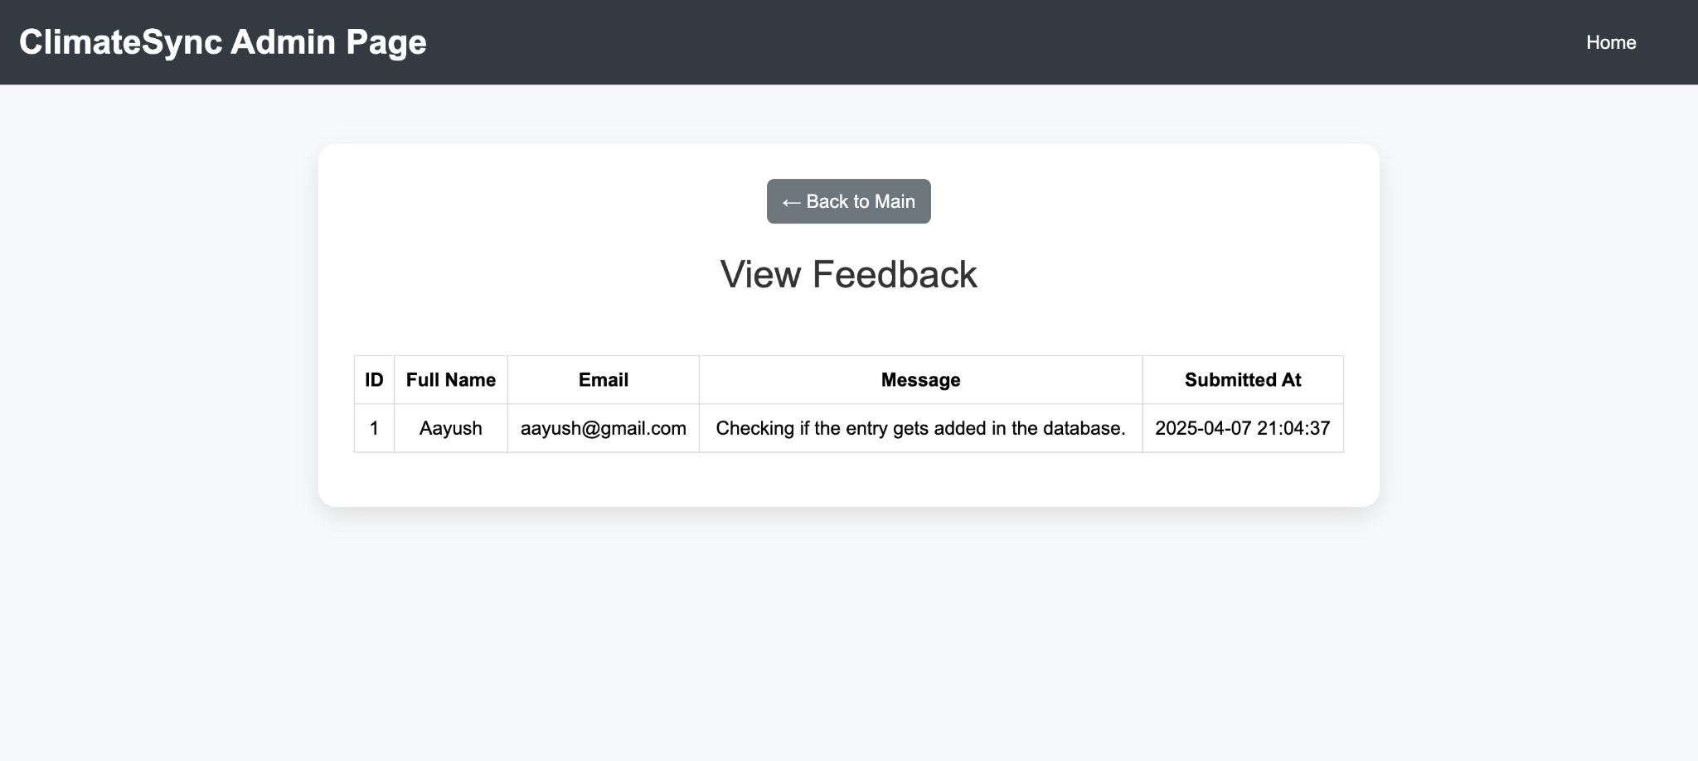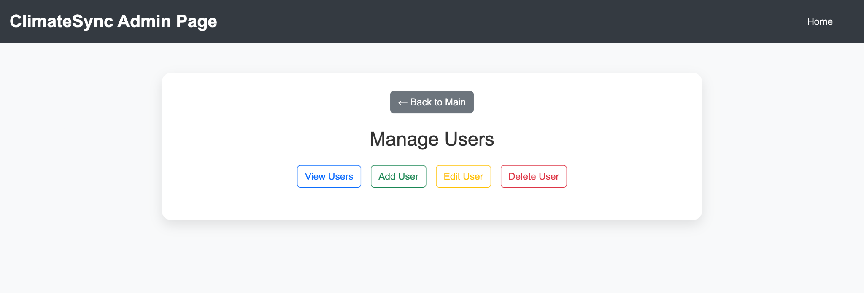

**Figma Design and Database Schema :**

**Figma Design :**

**HomePage :**

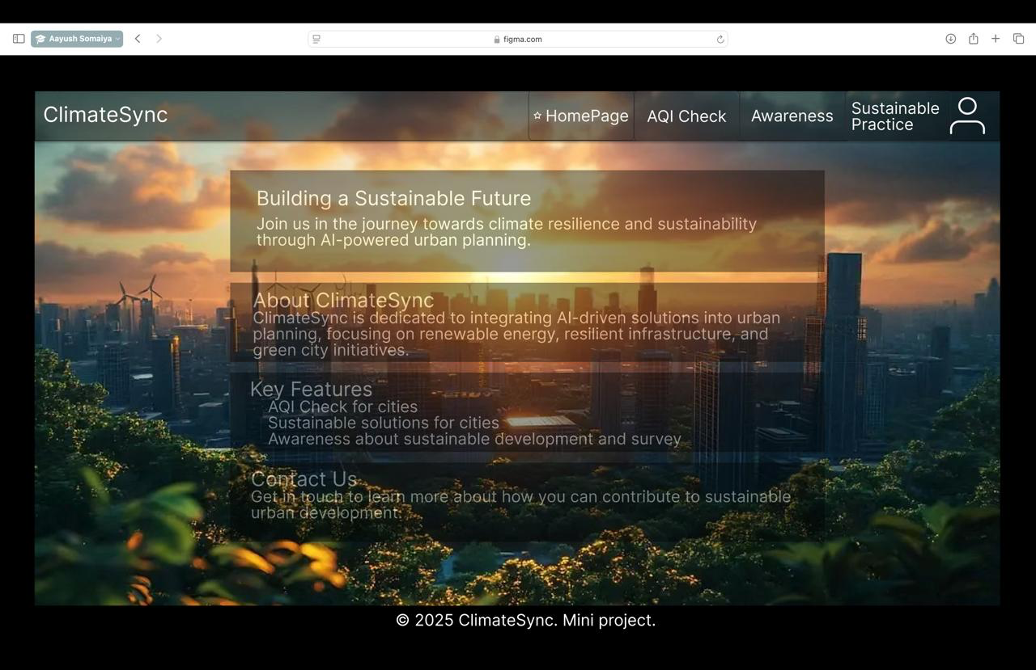

**AQI Check :**

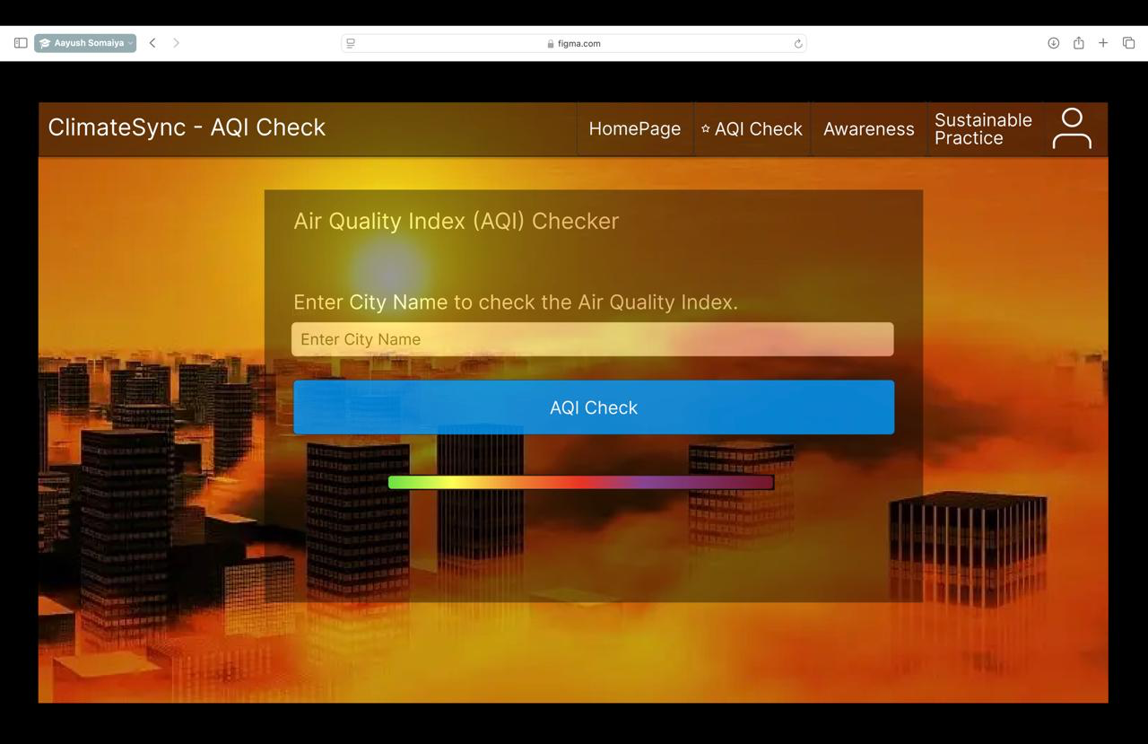

**Sustainable Practices :**

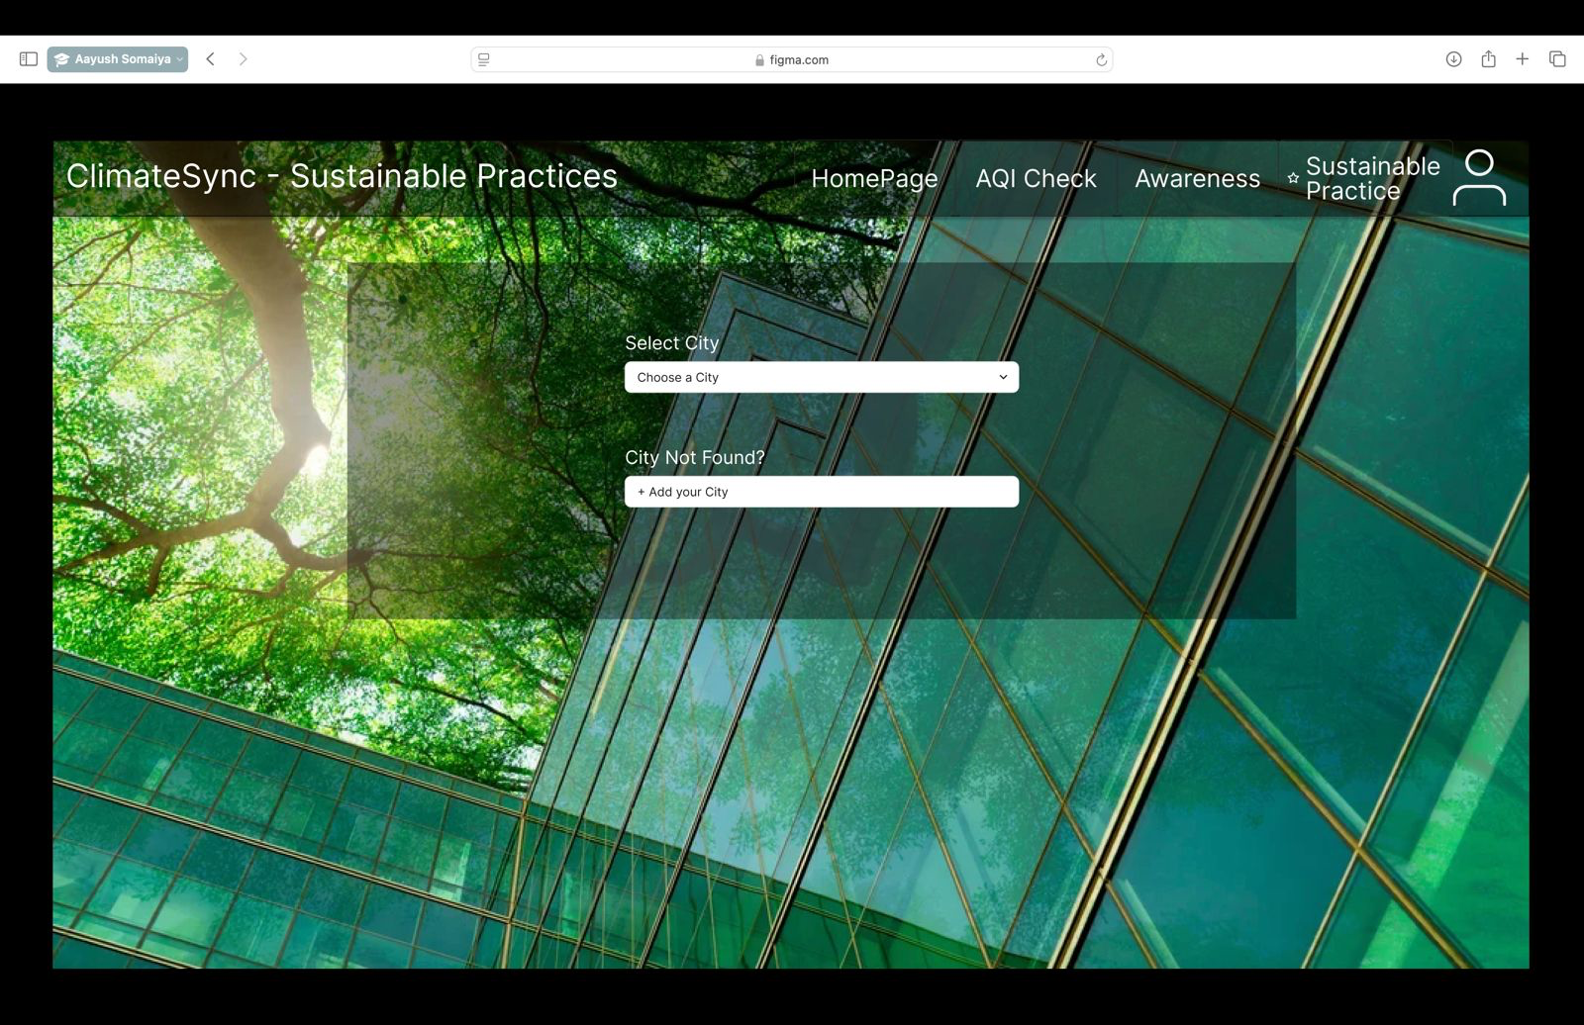

**Climate Awareness :**

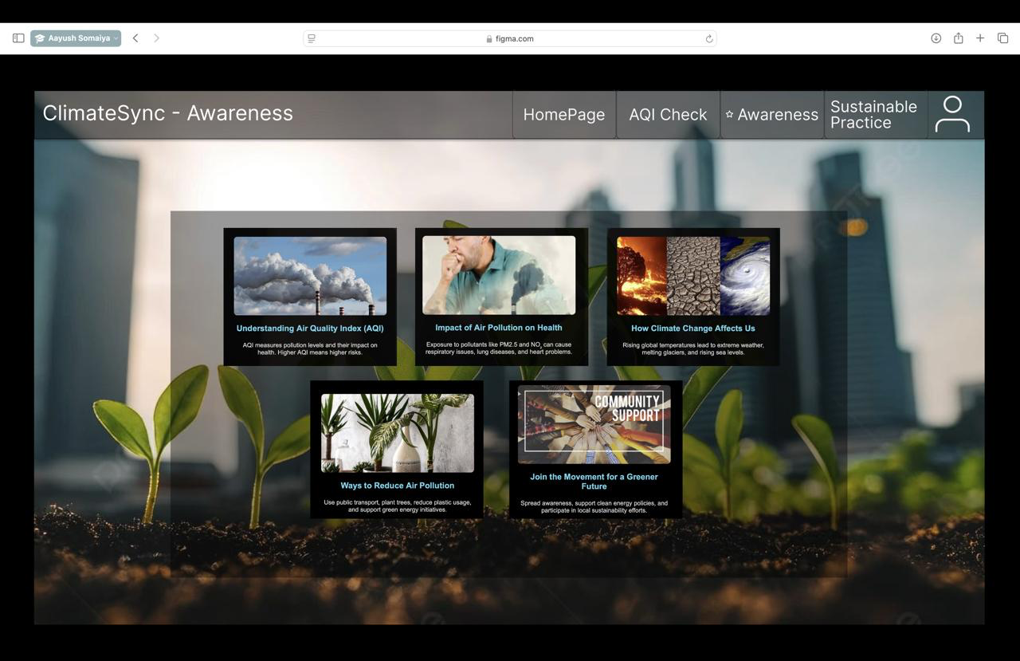

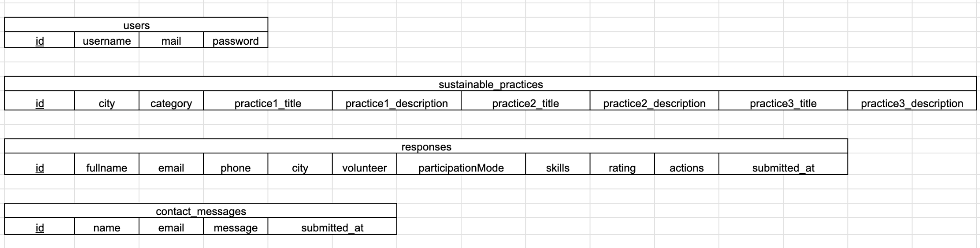**Schema :**

**Suggested Changes:**

1. Add color-coded Slider Bar to represent AQI

2. Create an Admin Functionality to make changes in the Database instead of using phpMyAdmin.

**All Suggested Changes have been incorporated and verified.**

**Conclusion :**

In conclusion, ClimateSync serves as a vital tool for promoting environmental awareness and encouraging sustainable actions at a personal and community level. By integrating real-time environmental data with practical, user-friendly sustainability practices, we have created a platform that empowers users to actively engage in climate action. The platform not only provides essential information but also fosters a sense of community where users can contribute their ideas, share knowledge, and help make their surroundings more sustainable. As students, we have learned a lot throughout this project, from technical development to understanding the importance of accessible environmental tools.

**Future Scope :**

In the future, *ClimateSync* can be enhanced by adding more city-specific data to make the platform even more personalized and useful for users across different regions. This could include integrating more environmental indicators like water quality, waste management,weather reports data. Artificial Intelligence can also be integrated to get live data.

Additionally, expanding the community engagement features could encourage more user participation. This could involve allowing users to share their own sustainable practices or collaborate on local environmental initiatives, creating a more active and connected user base.

**GitHub Repository link** : <https://github.com/AdityaSontakke23/mini-project>